**Product Training Assignment 1**

**Step 1:**

Create a local git repo with the name "MyRepo" and then create one .txt file, five .c files and five .java files in the working area.

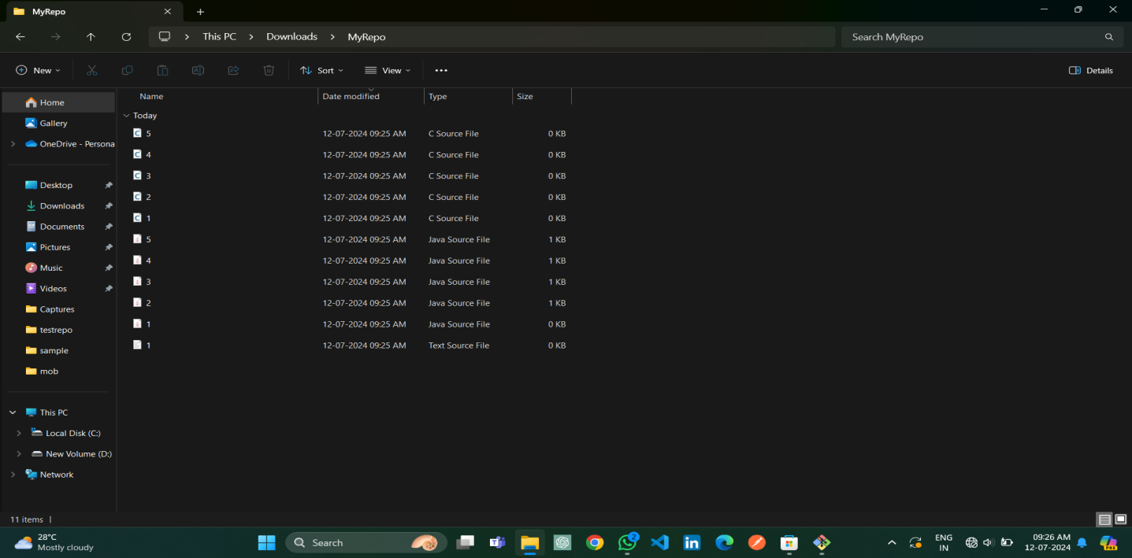

**Step 2:**

Verify the git status

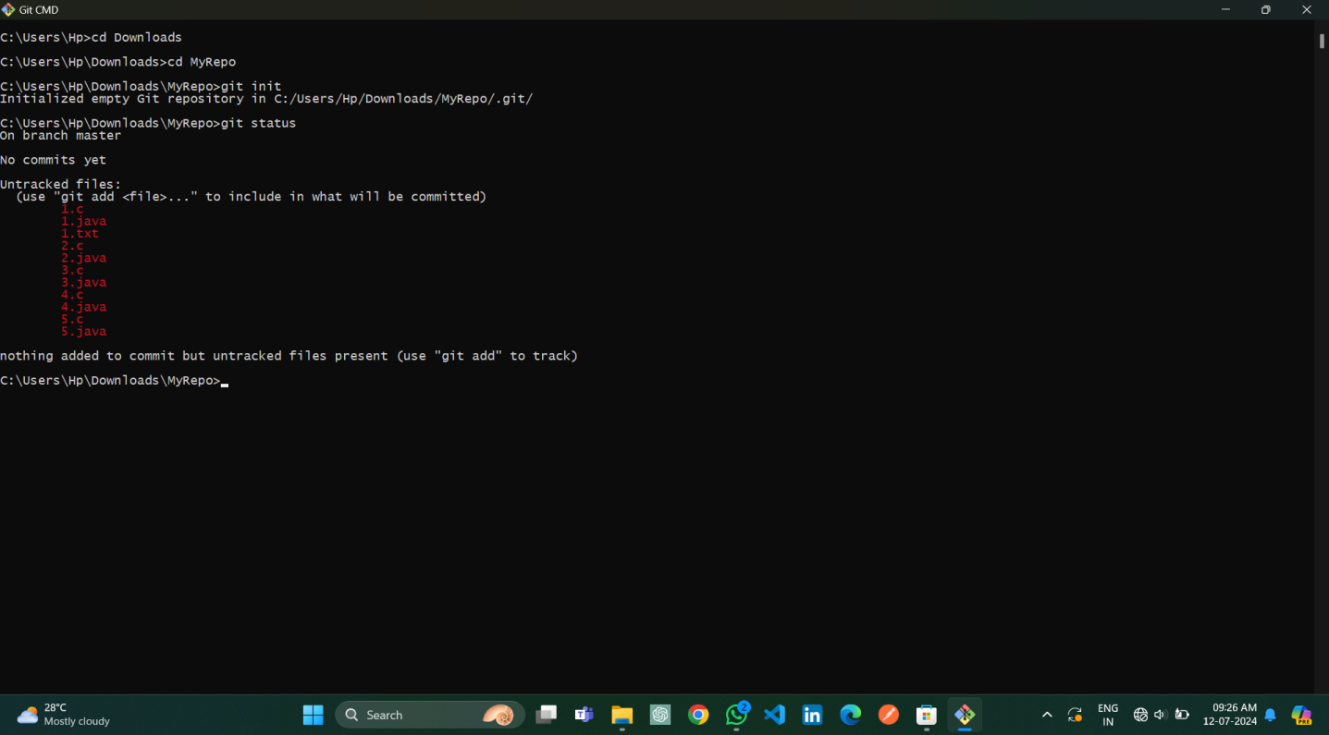

**Step 3:**

Add only the .txt into the staging area and verify the git status.

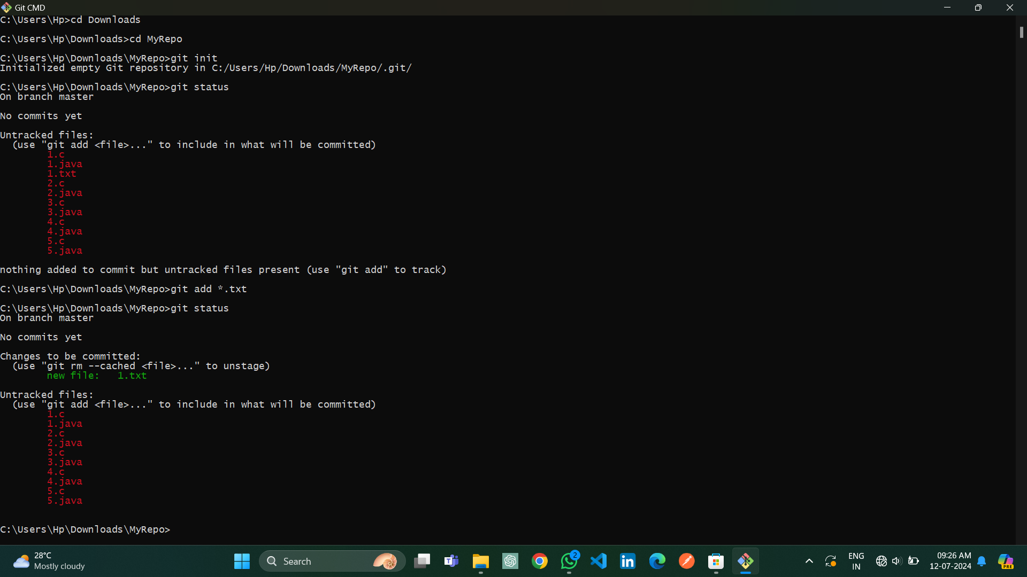

**Step 4:**

Make a commit with the name "TXT Commit".

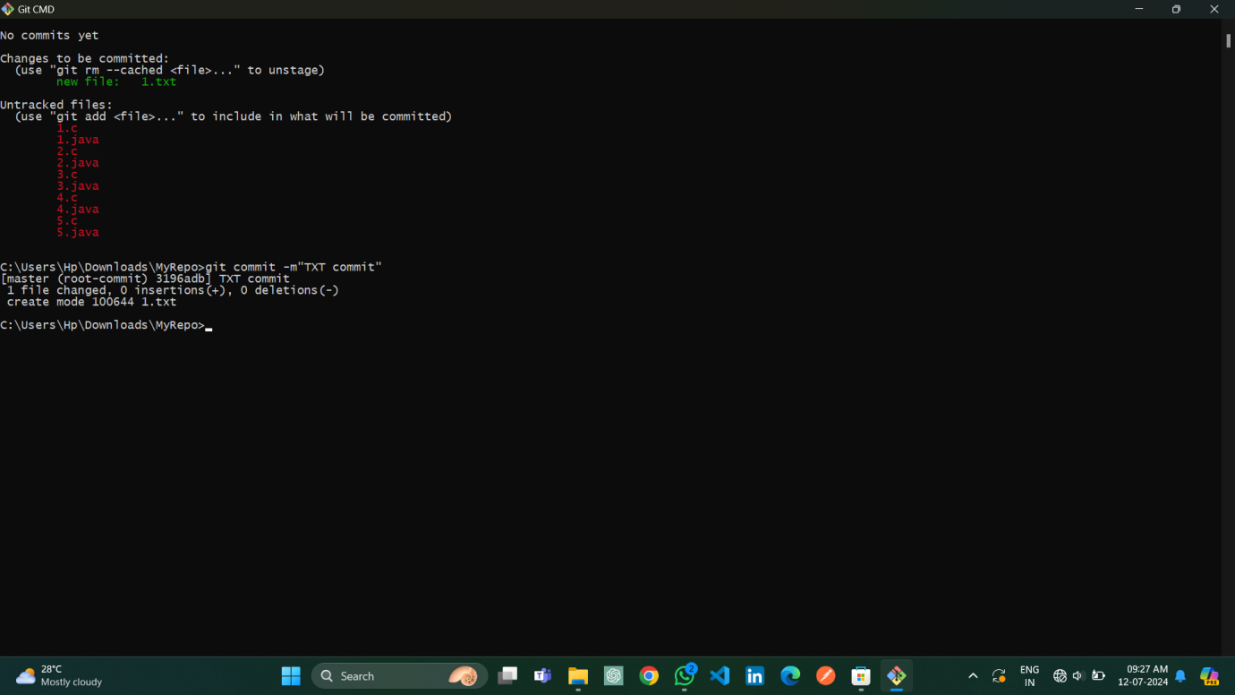

**Step 5:**

Add all .c files into the staging area and verify the git status.

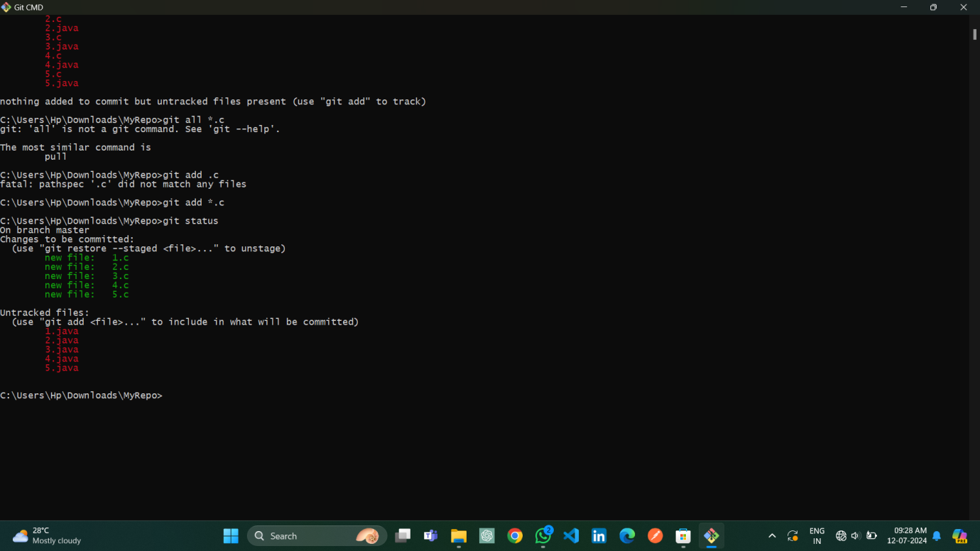

**Step 6:**

Make a commit with the name "C Commit".

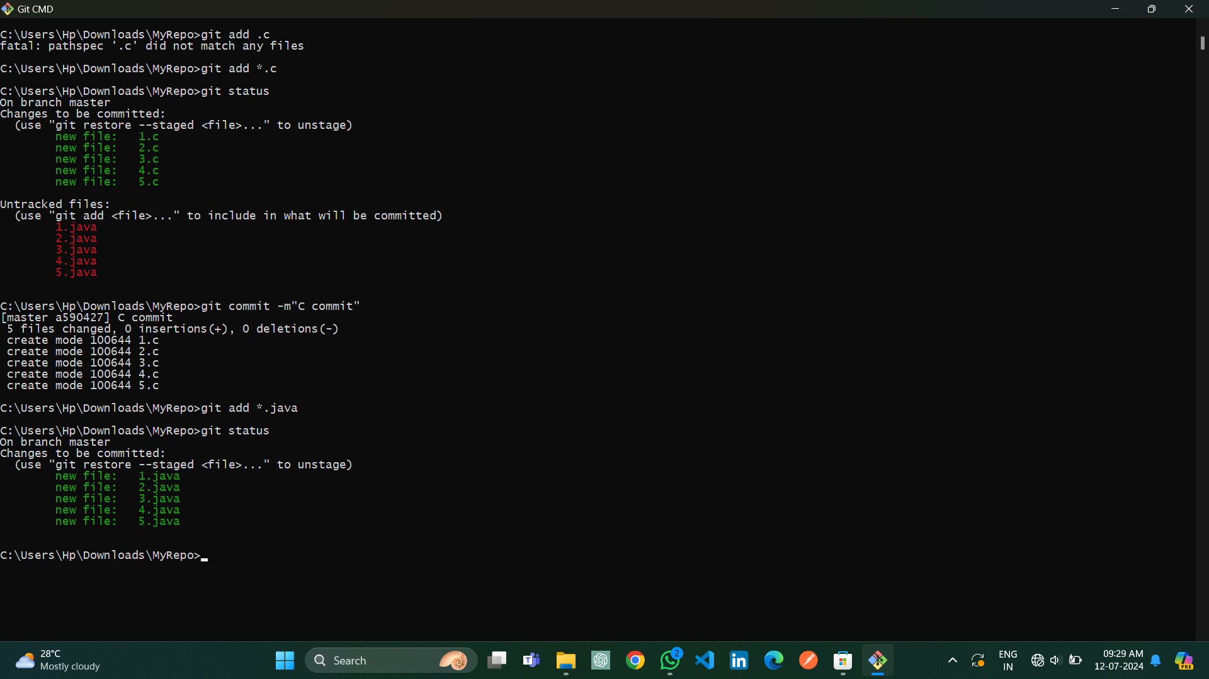

**Step 7:**

Add all .java files into the staging area and verify the git status and commit it.

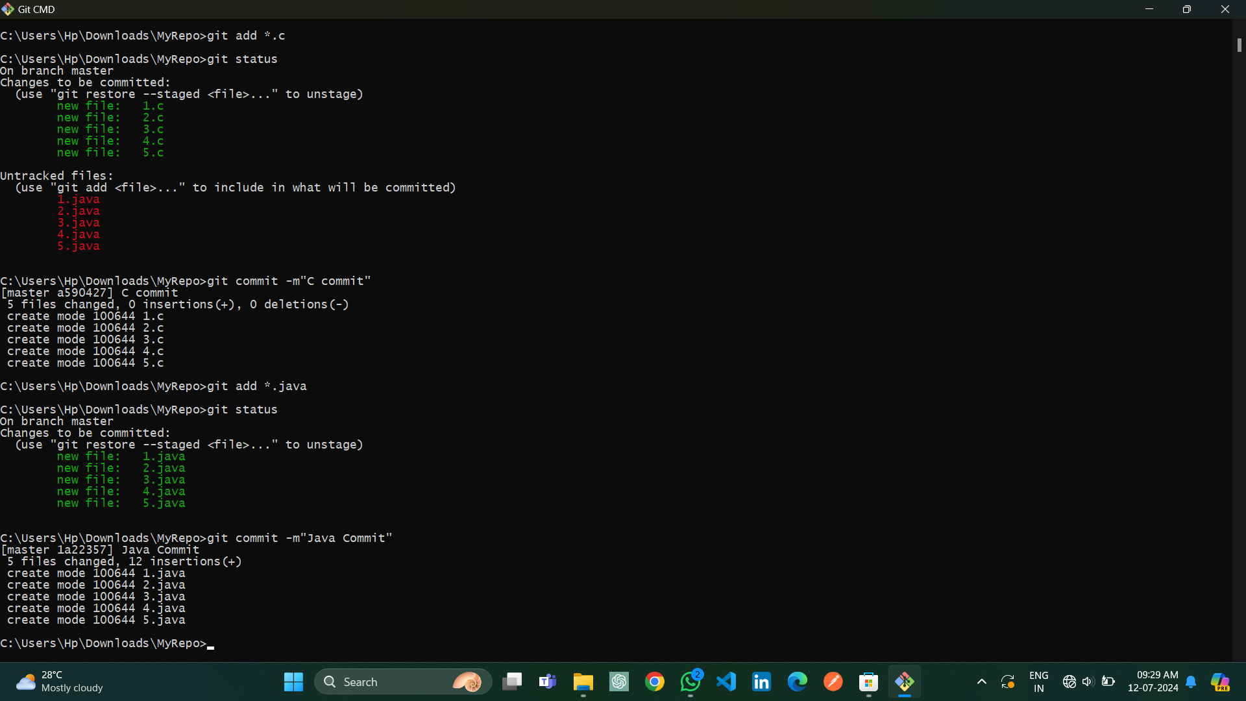

**Step 8:**

Delete all .java files from working area and see the status.

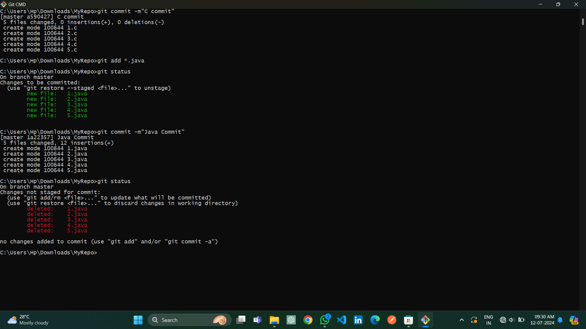

**Step 9:**

Add the changes into the staging area and make a commit with the name "Delete Java Commit".

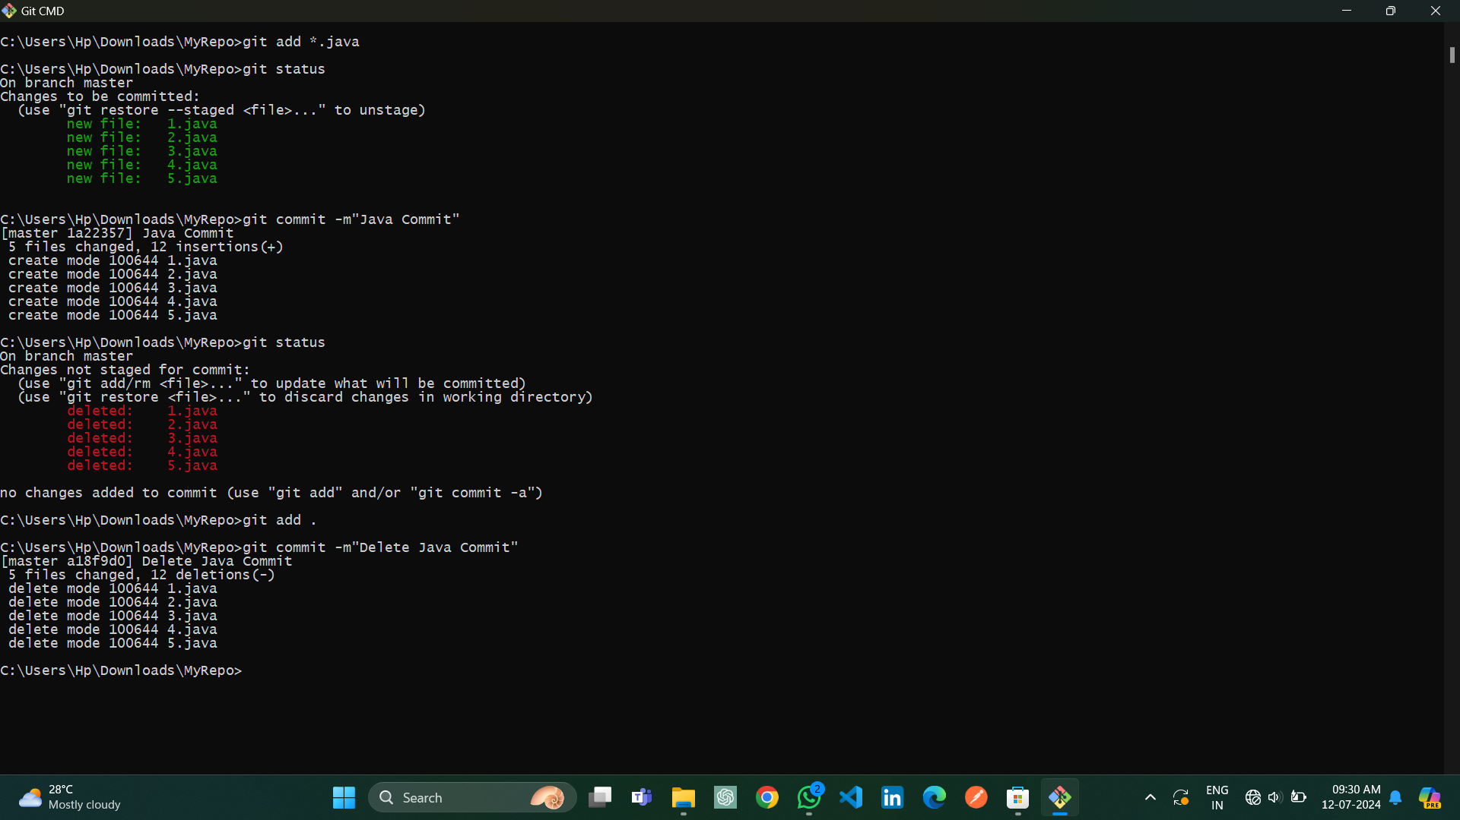

**Step 10:**

Display all commit details.

